[1]

Extraction of Fetal ECG Signal and Determination of Fetal Heart Rate

M. Do and E. Littell

*Abstract*—Determining fetal heart can be critical for monitoring the condition of a fetus. When an ECG signal is recorded by placing electrodes on the maternal abdomen, the fetal ECG is often masked by the maternal ECG signal and noise. By using an LMS adaptive filter to extract the fetal ECG signal, and then using the Pan & Tompkins algorithm to detect the QRS complexes, the fetal heart rate can be determined with very low percent error.

# INTRODUCTION

One of the concerns in neonatal care is determining the fetal heart rate. It is essential for monitoring the condition and well-being of a fetus, as it can aid in detecting arrhythmias or other such problems. Determining and monitoring the fetal heart rate is most often used during or near the onset of labor. One of the most important pieces of information that this provides is whether the baby is receiving enough oxygen.

LMS Adaptive Filter

Pan-Tompkins Algorithm

Direct Fetal ECG Signal

Abdominal Signal

Filtered fECG

Filtered Abdominal Signal

To detect the fetal heart rate, a Doppler ultrasound is commonly used during the pregnancy. This method consists, as the name suggests, of using ultrasound waves that are reflected by the fetal heart rate, altering the frequency of the waves. The doppler transforms this into a sound, so the heart rate can be heard and can be displayed on a screen. However, this method is not suitable for long term monitoring due to limited accessibility and it is not as reliable [1].

Electrocardiograms, or ECGs, are used to record electrical activity of the heart. Signals containing maternal and fetal ECG signals can be obtained by placing electrodes on the maternal abdomen. However, there are certain challenges when attempting to extract the fetal ECG signal from a signal containing the maternal and fetal ECG signals as well as noise. The amplitude of the QRS of the fetal signal is much smaller (order of microvolts) compared to the maternal signal (order of millivolts) [2]. This also means that regardless of where electrodes are placed on the body, the mother’s heartbeat will continue to generate noise that masks the signal of the fetus.

To overcome these challenges and ultimately determine the fetal heart rate, different methods have been applied. To obtain the fetal ECG signal, a cross-correlation function has been used, an averaged maternal ECG waveform was derived, and then a template signal of the maternal ECG was created using the averaged ECG waveform. To retrieve the averaged fetal ECG, the maternal ECG was subtracted from the original signal [3]. To de-noise the signal, the wavelet transform has been used. The wavelet analysis is similar to Fourier analysis; however, while FT breaks the signals into a series of sine waves at different frequencies, the wavelet transform breaks the signal into “wavelets” and uses inner products to measure similarities between the wavelets and signal [4]. Other methods that have been applied include independent component analysis [5] and the Pan and Tompkins algorithm [6] which involve using various filters, amplification techniques, and signal searching algorithms to extract the fetal ECG signal.

Our proposed method, shown in fig. 1, will be to use a Least Mean Square (LMS) adaptive filter to obtain just the fetal ECG signal, and then the newly obtained signal will be fed through the Pan and Tompkins algorithm to find the QRS complexes and thus obtain the fetal heart rate.

Figure 1. Proposed Method Block Diagram

# Method

The proposed method was developed and tested using the Abdominal and Direct Fetal Electrocardiogram Database from PhysioNet. The database contains multichannel fetal ECG recordings from 5 different women. Each woman was in labor and between 38 and 41 weeks of gestation when the recordings were obtained.

Each recording is composed of four signals acquired from the maternal abdomen in addition to a direct fetal ECG recorded from the fetal head. The four abdominal electrodes were placed around the navel while a reference electrode was placed above the pubic symphysis. A reference electrode was also placed on the left leg to ground the signal. The bandwidth of the signals was 1-150 Hz, the sampling rate was 1 kHz, and the resolution is 16 bits [7].

*A. Least Mean Square Adaptive Filter*

The main idea behind adaptive filtering is that a variable filter (shown as wn in fig 2.) is adjusted until the difference between the variable filter output and the desired signal is as small as possible. Fig. 2 shows the adaptive filter block diagram. An abdominal signal, x(n), is passed through the variable filter, which alters x(n) according to w(n), a vector composed of weights that controls the filter [8]. The output of the altered signal, represented by y(n), is then compared to d(n), the desired output. The difference between y(n) and d(n) is e(n), or the mean-square error. Next, the error signal and x(n) pass through the adaptive algorithm, which updates the filter coefficients to attempt to further reduce the error [9]. To update the filter coefficients (wn), the adaptive algorithm depends on the parameter μ. This is the step size of the adaptive filter. It affects the convergence speed (how quickly the error signal is minimized) and the steady state error (because the adaptive filter is not perfect, the error may not converge exactly to zero). A small step size corresponds to a small steady state error. However, it decreases the convergence speed [9]. When extracting the fetal ECG signal from the abdominal signal, the step sizes that were tested ranged from 0.40-0.85. From this range, the step size that provided the least percent error once fetal heart rate was calculated was chosen.

Figure 4. Pan & Tompkins Algorithm Block Diagram

Figure 2. LMS Adaptive Filter Block Diagram

wn

Adaptive Algorithm

Δwn

y(n)

d(n)

+

e(n)

x(n)

**-**

One other parameter that affects the adaptive filter is the order, or length, of the weight vector. Increasing the order should result in less noise, but it can also make the fetal heartbeat magnitude more difficult to detect [10]. In addition, the larger the order, the longer the processing time of the filter. When determining the order to use, the mean error was compared to the order, and as exemplified by fig. 3, when the order was greater than approximately 800, the mean error was constant. The order that was used was 1000.

Figure 3. Mean Error vs. Order

*B. Pan & Tompkins Algorithm*

Once the fetal ECG signal has been extracted from the abdominal signal, the Pan & Tompkins algorithm is used to locate the R waves (the block diagram can be seen in fig. 4.). The algorithm first preprocesses the signal to ensure that the sampling frequency is 200 Hz. Then a bandpass filter with a passband of 5-15 Hz is used to filter out noise. Although the signal has already been filtered by the adaptive filter, this additional filtration may aid in the removal of any lingering noise within this frequency range [1], [2].

Figure 5. An unfiltered abdominal signal obtained from patient 7.

y(n)

Pre-process

Bandpass Filter

$$\frac{d}{dt}$$

$$\int{dt}$$

Filtered

fECG

Next, a differentiator is used. With differentiation, the signal can be smoothed and the signal to noise ratio can be increased. In addition, this can aid in peak detection. By determining the points where the signal crosses the x-axis (zero crossings), and by determining if the slope is greater than an established slope threshold (again to help reduce the effect of noise), the possible peaks of the signal can be located [8]. The new signal is then squared to obtain positive values and, more importantly, to emphasize the larger frequencies [2].

After differentiation, and integrator is needed. The Pan and Tompkins algorithm uses a moving-window integration to gain more information on the waveform [2]. With the location of the R waves known, heart rate (beats/minute) can be calculated as 1000*(60)/(RR interval (milliseconds)). The method is applied to each of the four signals obtained from the four electrodes, and the calculated heart rates can be compared to the direct fetal ECG signal that is recorded from the electrode placed on the fetal scalp. To determine the accuracy of the method, percent error is calculated.

# Results

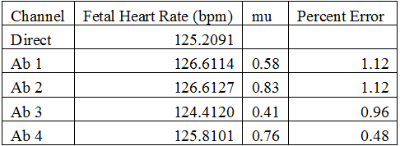Table I shows the fetal heart rate calculated using the direct signal, the fetal heart rate calculated using each abdominal signal, the step size used to obtain each heart rate, and the percent error between the reference heart rate and the calculated heart rate for one patient. Figs. 5, 6, and 7 show an abdominal signal, the desired output, and the output signal, respectively, for the same patient. The output signal shown in fig. 7 closely resembles the desired output shown in fig. 6. The effectiveness of the filtering method can also be seen by the low percent errors shown in the table. For each abdominal signal tested for this patient, the percent error was below 2%. Overall, nearly all the calculated fetal heart rates had a percent error lower than 5%. It should be noted 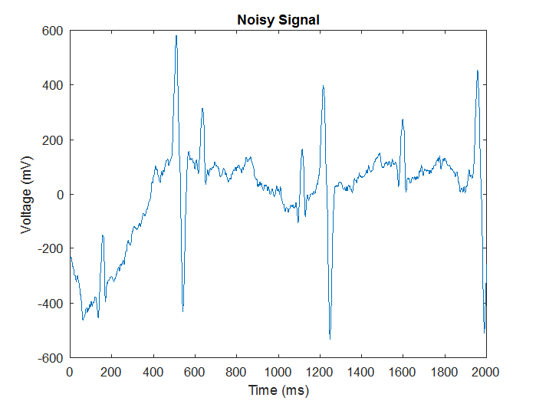that the step sizes did vary noticeably, and calculating the heart rate for each abdominal signal required a longer processing time.

TABLE I.

Calculated fetal heart rates for Patient 07.

# Using Averaged Abdominal Signal

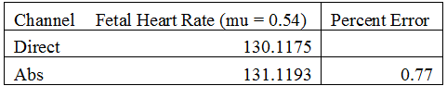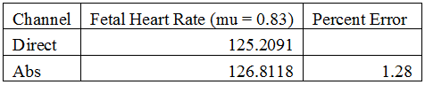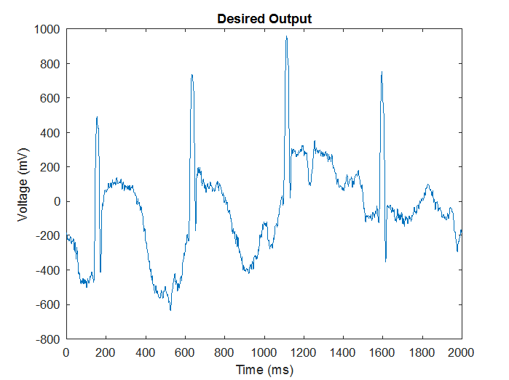To decrease the time required to calculate the fetal heart rate, the four abdominal signals were averaged. As a result, only one step size needed to be found. Tables II and III show the results of two patients. Overall, the percent error for one patient was 5.31%, but the other four patients had percent errors below 5%.

TABLE III.

Calculated fetal heart rate using the average abdominal signal for Patient 08.

TABLE II.

Calculated fetal heart rate using the average abdominal signal for Patient 07.

Figure 5. Abdominal signal obtained from Patient 07.

# Conclusion

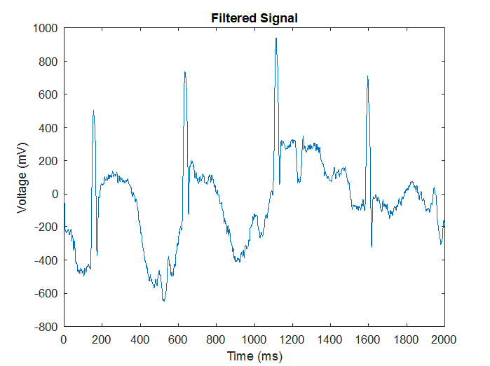It has been shown that the LMS adaptive filter, in combination with the Pan & Tompkins algorithm, is effective in determining fetal heart rate. However, a limitation of the method explored in this proposal is that a direct fetal scalp signal is required for the desired output of the adaptive filter. The optimal method for determining fetal heart rate would involve a noninvasive approach, as this would allow for greater comfort for the mother, greater ease when attaching the electrodes, and the method could be used prior to labor. A possible modification to the process would be to use the maternal ECG, obtained from electrodes placed on the mother’s thoracic cavity, as the desired output. If the input remained the same­– the abdominal signal that contains the maternal ECG, fetal ECG, and noise– then the error signal of the LMS adaptive filter would contain the fetal heartbeat. Using the Non-invasive Fetal ECG Database on PhysioNet, this modification was tested. The resulting fetal heart rates were, for the most part, in the proper range of 120-160 bpm. However, because there was no direct fetal scalp lead, the accuracy of these results cannot be determined. As such, this modification requires further exploration.

Figure 6. Signal obtained from the direct fetal scalp electrode from Patient 07.

References

Figure 7. Output signal after using the LMS adaptive filter for Patient 07.

1. M. Ghodsi, H. Hassani, and S. Sanei, “Extracting fetal heart signal from noisy maternal ECG by multivariate singular spectrum analysis,” *Statistics and Its Interface*, vol. 3, pp. 399-411. 2010.
2. N. Marchon and G. Naik, "QRS detector for maternal abdominal ECG," *2016 International Conference on Signal and Information Processing (IConSIP)*, Vishnupuri, 2016, pp. 1-5.

doi: 10.1109/ICONSIP.2016.7857463

1. S. Abboud, A. Alaluf, S. Einav, D. Sadeh, “Real-Time Abdominal Fetal ECG Recording Using a Hardware Correlator,” *Comput. Biol Med.*, vol. 22, no. 5, pp. 325-335. 1992.
2. V. Vigneron, A. Paraschiv-Ionescu, A. Azancot, O. Sibony and C. Jutten, "Fetal electrocardiogram extraction based on non-stationary ICA and wavelet denoising," *Seventh International Symposium on Signal Processing and Its Applications, 2003. Proceedings.*, 2003, pp. 69-72 vol.2.

doi: 10.1109/ISSPA.2003.1224817

1. J. Szalai and F. E. Mozes, "Determining fetal heart rate using independent component analysis," *2014 IEEE 10th International Conference on Intelligent Computer Communication and Processing (ICCP)*, Cluj Napoca, 2014, pp. 11-16.

doi: 10.1109/ICCP.2014.6936973

1. J. Pan and W. J. Tompkins, "A Real-Time QRS Detection Algorithm," in *IEEE Transactions on Biomedical Engineering*, vol. BME-32, no. 3, pp. 230-236, March 1985.  
   doi: 10.1109/TBME.1985.325532
2. Goldberger AL, Amaral LAN, Glass L, Hausdorff JM, Ivanov PCh, Mark RG, Mietus JE, Moody GB, Peng C-K, Stanley HE. PhysioBank, PhysioToolkit, and PhysioNet: Components of a New Research Resource for Complex Physiologic Signals. *Circulation* **101**(23):e215-e220 [Circulation Electronic Pages; <http://circ.ahajournals.org/content/101/23/e215.full>]; 2000 (June 13).
3. B. Paul and P. Mythili, "ECG noise removal using GA tuned sign-data least mean square algorithm," 2012 IEEE International Conference on Advanced Communication Control and Computing Technologies (ICACCCT), Ramanathapuram, 2012, pp. 100-103.  
   doi: 10.1109/ICACCCT.2012.6320750
4. Ni.com. (2017). *Least Mean Square (LMS) Adaptive Filter - National Instruments*. [online] Available at: http://www.ni.com/example/31220/en/ [Accessed 16 Dec. 2017].
5. M. Wasimuddin and N. Gupta, "Design and implementation of Least Mean Square adaptive filter on fetal electrocardiography," Proceedings of the 2014 Zone 1 Conference of the American Society for Engineering Education, Bridgeport, CT, 2014, pp. 1-5.  
   doi: 10.1109/ASEEZone1.2014.6820650

1.